Chapter 2

PROJECT MANAGEMENT
________________________________________________

  - PROJECT PLANNING AND SCHEDULING

Project planning is part of project management, which relates to the use of schedules such as Gantt charts to plan and subsequently report progress within the project environment. Initially, the project scope is defined and the appropriate methods for completing the project are determined. Following this step, the durations for the various tasks necessary to complete the work are listed and grouped into a work breakdown structure. The logical dependencies between tasks are defined using an activity network diagram that enables identification of the critical path. Float or slack time in the schedule can be calculated using project management software. Then the necessary resources can be estimated and costs for each activity can be allocated to each resource, giving the total project cost. At this stage, the project plan may be optimized to achieve the appropriate balance between resource usage and project duration to comply with the project objectives. Once established and agreed, the plan becomes what is known as the baseline. Progress will be measured against the baseline throughout the life of the project. Analyzing progress compared to the baseline is known as earned value management

Project Development Approach

We have used Iterative and Incremental Development model (IID) for our project development. This development approach is also referred to as Iterative Waterfall Development approach. Iterative and Incremental Development is a software development process developed in response to the more traditional waterfall model.

Life Cycle:
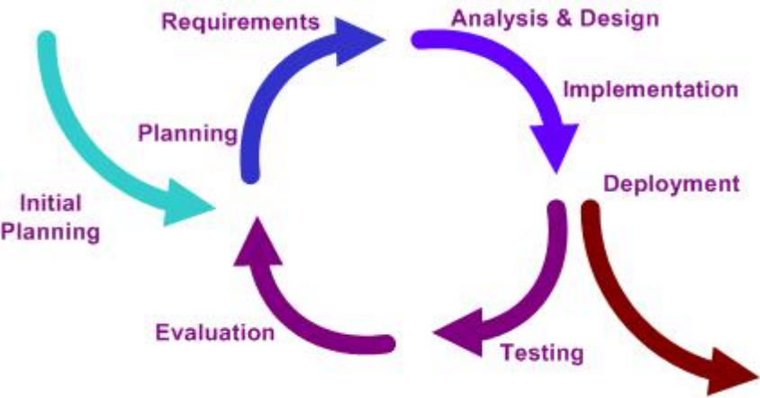
Figure 2.1: Iterative and Incremental Life Cycle

The basic idea behind iterative enhancement is to develop a software system incrementally, allowing the developer to take advantage of what was being learned during the development of earlier, incremental, deliverable versions of the system. Learning comes from both the development and use of the system, where possible. Key steps in the process were to start with a simple implementation of a subset of the software requirements and iteratively enhance the evolving sequence of versions until the full system is implemented.

At each iteration, the procedure itself consists of the Initialization step, the Iteration step, and the Project Control List. The initialization step creates a base version of the system. The goal for this initial implementation is to create a product to which the user can react. It should offer a sampling of the key aspects of the problem and provide a solution that is simple enough to understand and implement easily. To guide the iteration process, a project control list is created that contains a record of all tasks that need to be performed. It includes such items as new features to be implemented and areas of redesign of the existing solution. The control list is constantly being revised as a result of the analysis phase.

The iteration involves the redesign and implementation of a task from project control list, and the analysis of the current version of the system. The goal for the design and implementation of any iteration is to be simple, straightforward, and modular, supporting redesign at that stage or as a task added to the project control list. The code can, in some cases, represent the major source of documentation of the system. The analysis of an iteration is based upon user feedback, and the program analysis facilities available. It involves analysis of the structure, modularity, usability, reliability, efficiency, and achievement of goals. The project control list is modified in light of the analysis results.

During the implementation of the project by this approach, a step called V&V i.e. Verification and Validation is carried out at certain intervals.
- Verification: “Are we building the product right?”
- Validation: “Are we building the right product?”

Project Plan

Once we examine that the project is feasible, we undertake project planning. The table below describes how we planned our project.
Table 2.1 Project Plan
Phases | Time Period | No. of days | Deliverables of the phase
Feasibility Analysis | 17th Jan. – 22th Jan. | 6 | Feasibility Report document
Requirement Gathering | 23th Jan. – 01st Feb. | 10 | System Requirement Study
Analysis | 02nd Feb. – 10th Feb. | 09 | System Requirement Study
Design | 11th Feb. – 05th Mar. | 23 | Design document
Implement Coding | 06th Mar. – 9th April. | 35 | Implementation of system
Testing | 10th April. – 13th April. | 4 | Testing Document
Final Evaluation | 20th April. | 1 | Report Submit

Roles and Responsibilities
Table 2.2 Roles and Responsibilities
Role | Responsibility |  | Team/Member
Project Guide | Defining scope |  | Mr. Dhaval Patel
Project Guide | Providing required resources |  | Mr. Dhaval Patel
Project Guide | Project planning, tracking and monitoring. |  | Mr. Dhaval Patel
Project Guide | Analysis and Effort Estimation. |  | Mr. Dhaval Patel
Project Guide | Coordination between project teams. |  | Mr. Dhaval Patel
Project Developer | Designing & Documentation | Self
Project Developer | Execution project as per defined schedule.
Project Developer | Reporting to PL
Project Developer | Testing & QA/QC
Project Developer | Software development as per the design and Documentation

    - Schedule Representation

Scheduling the project tasks is an important project planning activity. It involves deciding which tasks would be taken up when. In order to schedule the project activities, a software project manager needs to do the following:

- Identify all the tasks needed to complete the project.
- Break down large tasks into small activities.
- Determine the dependencies among different activities.
- Establish the most likely estimates for the time durations necessary to complete the activities.
- Allocate resources to activities.
- Plan the starting and ending dates for various activities.
- Determine the critical path. A critical path is the chain of activities that determines the duration of the project.

Work Breakdown Structure
Advantage Immigration

Requirement Specification
Design
Code
Test
Document

Database part
Graphical user interface part
Database part
Graphical user interface part

Figure 2.2: Work breakdown structure of Advantage Immigration System

Design database part
Code database part

Specification
Integrate and test
Code GUI part
Design
GUI part
Finish

Write user manual

Figure 2.3: Activity Network representation of Advantage Immigration System

Gantt chart

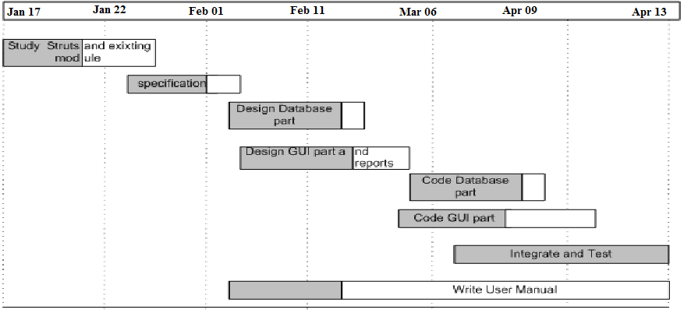

Figure 2.4: Gantt chart

  - RISK MANAGAMENT

Software Risk Management is a proactive approach for minimizing the uncertainty and potential loss associated with a project. Some categories of risk include product size, business impact, customer-related, process, technology, development environment, staffing (size and experience), schedule, and cost. Risk Management is a practice with processes, methods, and tools for managing risks in a project. It provides a disciplined environment for proactive decision making to

- Assess continuously what could go wrong (risks)
- Determine which risks are important to deal with
- Implement strategies to deal with those risks

    - Risk Identification

Risk identification is a systematic attempt to specify threats to the project plan. By identifying known and predictable risks, we can take a first step toward avoiding them when possible and controlling them when necessary. To perform the risk identification, we categorized the risk into different categories as:

    - Project Risk
    - Technical Risk
    - Business Risk
    - Known Risk
    - Predictable Risk
    - Unpredictable Risk

A. Project Risk:

The Project Risk threatens the project plan. The project risks here are:
A1. Schedule slippage.
A2. Incomplete requirement specification.
A3. Change in user Requirements.
A4. Non-availability of required resources.
A5. Lack of communication with end user.
A6. Improper vision about the project.
A7. Staffing and organization problems.
A8. Non-technical customer with high technical expectations.

B. Technical Risk:

The Technical Risk threatens the quality and timeliness of the software to be produced. If the technical risk becomes a reality, implementation may become difficult or impossible. The technical risks identified in our project are:
B1. Unavailable library files.
B2. Problem in connection to database server.
B3. Problem in application server.
B4. Problem in browser view.

C. Business Risk:

The Business Risk threatens the viability of the software to be built.
C1. Project not delivered on time.
C2. Switching of database structure.

D. Predictable Risk:

The Predictable risks are extrapolated from past project experience. Since we have not done any live industry project during the academic years, the predictable risks were very few. The predictable risk include mainly:
D1. Language error predictions.
D2. Lack of End user support in future project enhancement.

E. Unpredictable Risk

The Unpredictable risks are the joker in the deck. They can and do occur, but they are extremely difficult to identify in advance.

    - Risk Analysis

Each identified risk is considered and the effect and probability of each risk is identified during risk analysis.

    - Risk Planning

Risk planning lists the checkpoints that are made continually to find out situation where the risk can becomes reality.
- Plan entire schedule on paper in the beginning and follow it.
- Understand the scope from external guide to have the correct design.
- Find out proper documentation, manuals and guides from the person having the required knowledge.
- Schedule should not be delayed too much.
- Take backups regularly.
- Perform thorough requirement gathering and analysis. Confirm the collected requirements with the guide.

  - ESTIMATION

The estimation of various project parameters is a basic project planning activity. The important project parameters that are estimated include: project size, effort required to develop the software, project duration and cost. These estimates not only help in quoting the project cost to the customer, but also prove useful in resource planning and scheduling.

There are three broad categories of estimation techniques:
- Empirical estimation techniques
- Heuristic techniques
- Analytical estimation techniques

COCOMO (Constructive Cost estimation Model) – Heuristic technique
The basic COCOMO model gives an approximate estimate of the project parameters. The basic COCOMO estimation model is given by the following expressions:

Effort = a1 * (KLOC) ^{a2} PM
Tdev = b1 * (Effort) ^{b2} months

Where a1, a2, b1, b2 are constants for each category of software process. KLOC is the estimated size of product in Kilo Lines of Code. Tdev is the estimated time to develop the software, expressed in months. Effort is the total effort required to develop the software product, expressed in person month.

The COMOMO model estimation can be classified into three categories
- Organic
- Semidetached
- Embedded

2.3.1 Effort estimation

We followed the most common and feasible approach for estimating the effort required in the software development in which project size is variable and the equation of the effort is given by

EFFORT = a * SIZE ^{b}.

According to the survey and analysis carried out at IBM Federal System Division, if the size estimate is in KDLOC and the project is ranging from 4000 to 467000 lines of delivered source code then the equation for total effort, E, in person months (PM) can be given by

E = 4.1 * 5 ^{0.7} = 12.64 PM.

Where 3.2 and 0.7 are values of a and b determined depending upon the data about the projects that has been performed in the past.

2.3.2 Duration estimation

As mentioned earlier we used the survey and analysis results given by IBM Federal System Division and according to those results the total duration, D , in calendar months can be estimated by the equation

D = a * E ^{b}.

Again determining the values of a and b from the data about the projects that has been performed in the past we get the equation
D = 2.3 * 12.64 ^{0. 38} = 6.03 Months.

